Questions 1 - 10
Complete the notes below. Write ONE WORD AND/OR A NUMBER for each answer.
HIRING A PUBLIC ROOM
Example
● the Main Hall – seats 200
Room and cost
● the 1 Room – seats 100
● Cost of Main Hall for Saturday evening: £2 + £250 deposit (3 payment is required)
● Cost includes use of tables and chairs and also 4
● Additional charge for use of the kitchen: £25
Before the event
● Will need a 5 licence
● Need to contact caretaker (Mr Evans) in advance to arrange 6
During the event
● The building is no smoking
● The band should use the 7 door at the back
● Don't touch the system that controls the volume
● For microphones, contact the caretaker
After the event
● Need to know the 8 for the cleaning cupboard
● The 9 must be washed and rubbish placed in black bags
● All 10 must be taken down
● Chairs and tables must be piled up

Questions 11 - 20

Questions 11 – 14
Complete the notes below. Write ONE WORD for each answer.
Advice about visiting the farm
Visitors should:
● take care not to harm any 11
● not touch any 12
● wear 13
● not bring 14 into the farm, with certain exceptions.

Questions 15 – 20

MAP OF THE FARM
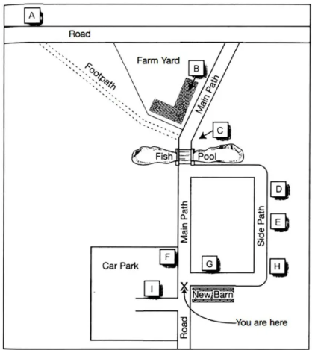
Label the map below.Write the correct letter A–I next to questions 15–20.

ALocation ABLocation BCLocation CDLocation DELocation EFLocation FGLocation GHLocation HILocation I
15.Scarecrow
16.Maze
17.Café
18.Black Barn
19.Covered picnic area
20.Fiddy House

Questions 21 - 30
Choose the correct letter A, B or C.
21.The students in Akira Miyake's study were all majoring in
A.physics.B.psychology or physics.C.science, technology, engineering or mathematics.
22.The aim of Miyake's study was to investigate
A.what kind of women choose to study physics.B.a way of improving women's performance in physics.C.whether fewer women than men study physics at college.
23.The female physics students were wrong to believe that
A.the teachers marked them in an unfair way.B.the male students expected them to do badly.C.their test results were lower than the male students'.
24.Miyake's team asked the students to write about
A.what they enjoyed about studying physics.B.the successful experiences of other people.C.something that was important to them personally.
25.What was the aim of the writing exercise done by the subjects?
A.to reduce stress.B.to strengthen verbal ability.C.to encourage logical thinking.
26.What surprised the researchers about the study?
A.how few students managed to get A grades.B.the positive impact it had on physics results for women.C.the difference between male and female performance.
27.Greg and Lisa think Miyake's results could have been affected by
A.the length of the writing task.B.the number of students who took part.C.the information the students were given.
28.Greg and Lisa decide that in their own project, they will compare the effects of
A.two different writing tasks.B.a writing task with an oral task.C.two different oral tasks.
29.The main finding of Smolinsky's research was that class teamwork activities
A.were most effective when done by all-women groups.B.had no effect on the performance of men or women.C.improved the results of men more than of women.
30.What will Lisa and Greg do next?
A.talk to a professor.B.observe a science class.C.look at the science timetable.

Questions 31 - 40
Complete the notes below. Write ONE WORD ONLY for each answer.
Ocean Biodiversity
Biodiversity hotspots
● areas containing many different species
● important for locating targets for 31
● at first only identified on land
Boris Worm, 2005
● identified hotspots for large ocean predators, e.g. sharks
● found the ocean hotspots:
•were not always rich in 32
•had higher temperatures at the 33
•had sufficient 34 in the water
Lisa Ballance, 2007
● looked for hotspots for marine 35
● found these were all located where ocean currents meet
Census of Marine Life
● found new ocean species living
•under the 36
•near volcanoes on the ocean floor
Global Marine Species Assessment
● want to list endangered ocean species, considering:
– population size
– geographical distribution
– rate of 37
● Aim: to assess 20,000 species and make a distribution 38 for each one
Recommendations to retain ocean biodiversity
● increase the number of ocean reserves
● establish 39 corridors (e.g. for turtles)
● reduce fishing quotas
● catch fish only for the purpose of 40

